TMT/Power electricals/S0457/2025 09 -09- 2025

To,
Power Electrical Engineers,
Mobile: 9848089363
Kukatpally, Hyderabad.

Dear sir,

Sub :- Supply of 20 MT C-TYPE HYDRAULIC PRESS.

This is reference to your enquiry for the hydraulic press; we offer our least possible price as under.

C TYPE PRESS :

1) Tonnage : 20 MT.

S No | Description of the unit | Offer/unit
1. | C Type Hydraulic Press with capacity 20 Tons. with Power pack of 5 HP motor and with complete electrical.  Clear pass 350 mm  Hydraulic power pack along with motor 5 hp motor  Tank 100 lts  Yuken vane pump 12 lpm  Pressure guage 1 No  Level indicator 1 No  Section filter 1 No  Return line filter 1 No  Section strainer 1 no  Manifold block 1 no  Pressure control valve 1 no  Solenoid operated direction control valve 1 no s  Pipes and fittings.  Bell housing 1 no  Pressure guage 0-250 kg 1 no  Flexible houses 2 nos  Nylon gear coupling 1 no | Rs 2,50,000/-

SPECIFICATIONS FOR THE HYDRAULIC PRESS MACHINE WITH 20 Ton

1. Tonnage : 20 M.T.

2. Clearance between Housings : 350mm

3. Daylight : 430 mm

4. Ram stroke. : 200 M.M.

5. Open height. : 530 M.M.

6. Closed height. : 330 M.M.

7. Depth of Throat. : 250 M.M.

- Ram speeds.

a) Approach. : 12 M.M. per Sec.

b) Pressing. : 2 M.M. per Sec.

c) Return. : 20 M.M. per Sec.

9. Motor capacity. : 5 H.P. (Crompton)

10. Bed size. : 350 x 450 M.M.

12. Cost of Machine. : Rs.2,50,000/- + Taxes.

13. Mode of payment. : As per the quotation.

14. Delivery. : As per the quotation.

GENERAL TERMS & CONDITIONS:

1 Price quoted per unit ex-work. Hyderabad.
2 Following charges are additional to your account.
- Freight Charge : As actual to be borne by you.
- Sales Tax : 18 % GST.
- Packing charge : As actual to be borne by you.
- Insurance : As actual to be borne by you.
3. Payment : 50% advance along with order another 25%
advance after 3 weeks from first advance and
balance before delivery but after inspection at our
works.
- Delivery : 5-6 weeks from date of techno-commercially clear
purchase order.
- Validity : One month from the date of submission.
- Inspection : Inspection at our works prior to dispatch.
- Warranty : The machine is warranted for a period of 12
months from the date of dispatch against any
manufacturing defects/faulty material or bad
workmanship of any part or component but not
against any kind of abnormal or improper use of
machine. Defective part or component will be
replaced or repaired free of cost. Electrical
components are outside the scope of this
warranty.
- Commissioning : Erection & commissioning done by you, but if
required technical support & guidance provide by
us at additional cost.

NOTE:

- Oil is not in scope of our supply.
- Raw material for trial is arranged by you at your cost.

We are sure you will find our offer in line with your requirements. Should you require any further clarification please call us on mobile number 9246221106.

Thanking you and assuring you of our best services.

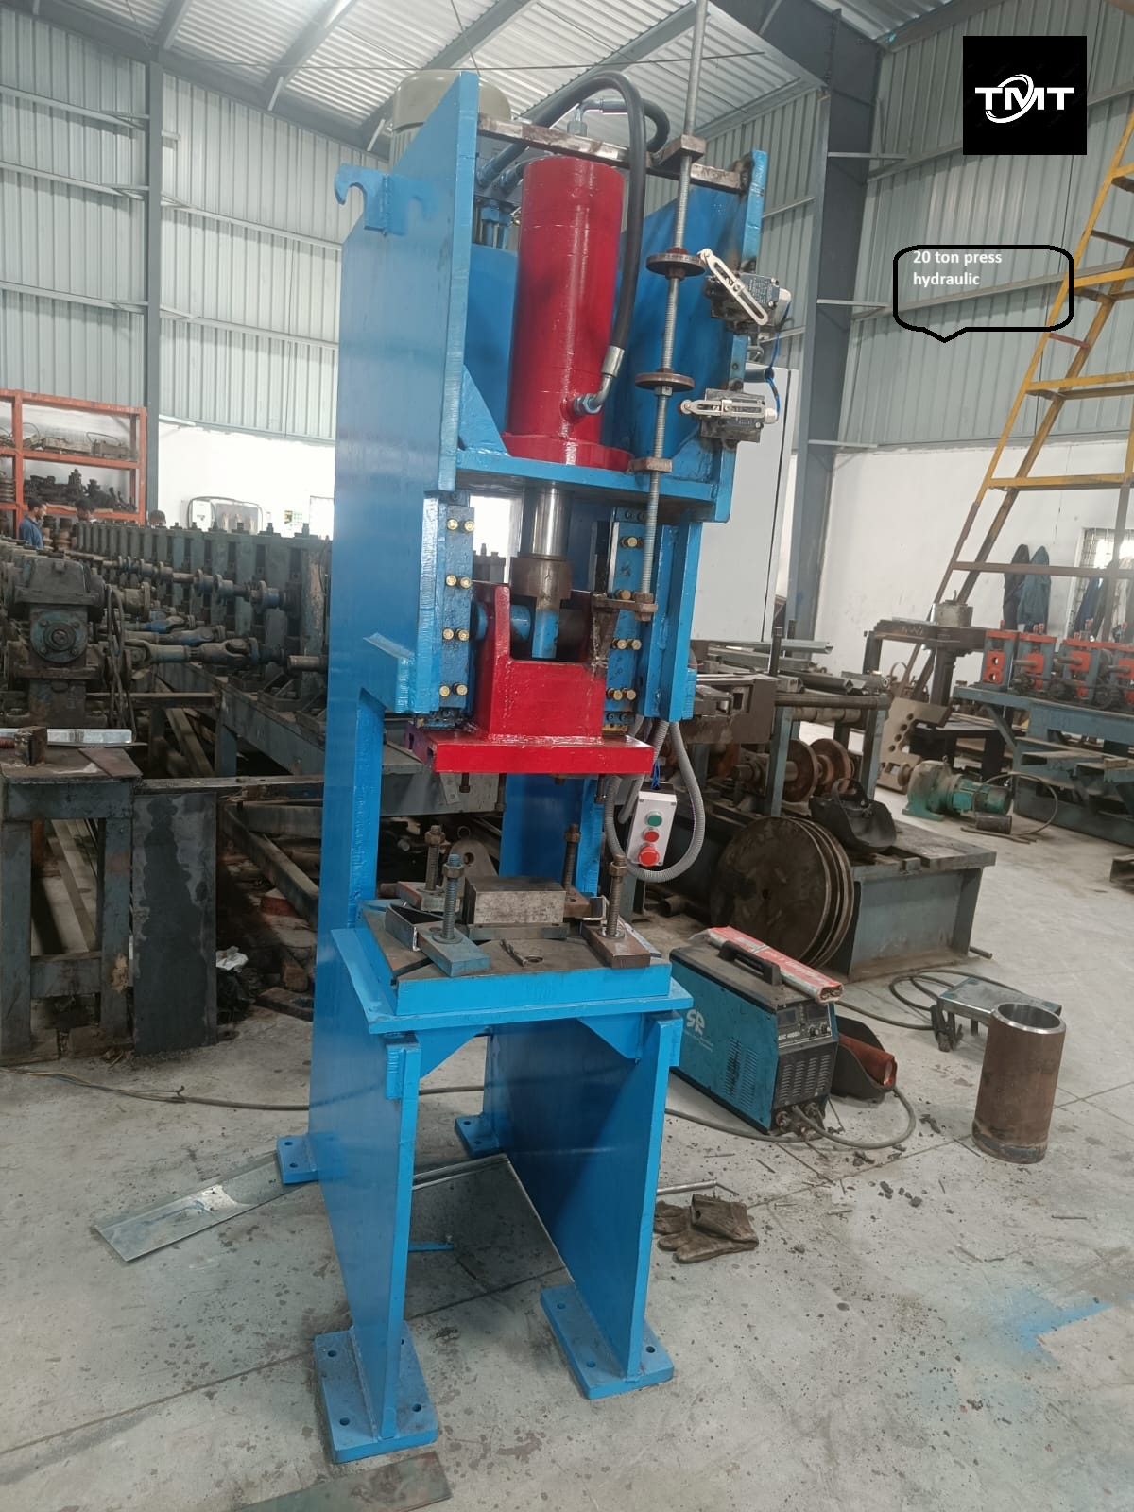

For TECHNO MACHINE TOOLS

T.SIVARAMAKRISHNA

TMT/Power electricals/S0457/2025 09 -09- 2025

To,
Power Electrical Engineers,
Mobile: 9848089363
Kukatpally, Hyderabad.

Dear sir,

Sub :- Supply of 50 MT C-TYPE HYDRAULIC PRESS.

This is reference to your enquiry for the hydraulic press; we offer our least possible price as under.

C TYPE PRESS :

1) Tonnage : 50 MT.

S No | Description of the unit | Offer
1. | C Type Hydraulic Press with capacity 50 Metric tons. with Power pack of 7.5 HP motor and with complete electrical.  Hydraulic power pack along with motor 7.5 hp motor  Tank 200 lts  Yuken vane pump 16 lpm  Piston pump 4.0 lpm  Pressure gauge 1 No  Level indicator 1 No  Section filter 1 No  Return line filter 1 No  Section strainer 1 no  Manifold block 1 no  Pressure control valve 1 no  Solenoid operated direction control valve 1 no’s  Pipes and fittings.  Bell housing 1 no  Pressure gauge 0-250 kg 1 no  Flexible houses 2 no’s  Nylon gear coupling 1 no | Rs 4,50,000/-  (Rupees Four Lakhs Fifty Thousand only)
2 | Punching tools 5 sets | Rs 75,000/- Rupees Seventy-Five Thousand Only

SPECIFICATIONS FOR THE HYDRAULIC PRESS MACHINE WITH 50Ton

1. Tonnage : 50 Ton.

2. Clearance between Housings : 1450mm

3. Daylight : 550 mm

4. Ram stroke. : 350 M.M.

5. Open height. : 450 M.M.

6. Closed height. : 100 M.M.

7. Depth of Throat. : 450 M.M.

- Ram speeds.

a) Approach. : 12 M.M. per Sec.

b) Pressing. : 2 M.M. per Sec.

c) Return. : 20 M.M. per Sec.

9. Motor capacity. : 10 H.P. (Crompton)

10. Bed size. : 750 x 550 M.M.

12. Cost of Machine. : Rs.4,50,000/- + Taxes.

13. Mode of payment. : As per the quotation.

14. Delivery. : As per the quotation.

GENERAL TERMS & CONDITIONS:

1 Price quoted per unit ex-work. Hyderabad.
2 Following charges are additional to your account.
- Freight Charge : As actual to be borne by you.
- Excise : 12.50%
- Sales Tax : 5% Vat.
- Packing charge : As actual to be borne by you.
- Insurance : As actual to be borne by you.
3 Payment : 50% advance along with order another 25%
advance after 3 weeks from first advance and
balance before delivery but after inspection at
our works.
- Delivery : 5-6 weeks from date of techno-commercially clear
purchase order.
- Validity : One month from the date of submission.
- Inspection : Inspection at our works prior to dispatch.
- Warranty : The machine is warranted for a period of 12
months from the date of dispatch against any
manufacturing defects/faulty material or bad
workmanship of any part or component but not
against any kind of abnormal or improper use of
machine. Defective part or component will be
replaced or repaired free of cost. Electrical
components are outside the scope of this
warranty.
- Commissioning : Erection & commissioning done by you, but if
required technical support & guidance provide by
us at additional cost.

NOTE:

- Oil is not in scope of our supply.
- Raw material for trial is arranged by you at your cost.

We are sure you will find our offer in line with your requirements. Should you require any further clarification please call us on mobile number 9246221106.

Thanking you and assuring you of our best services.

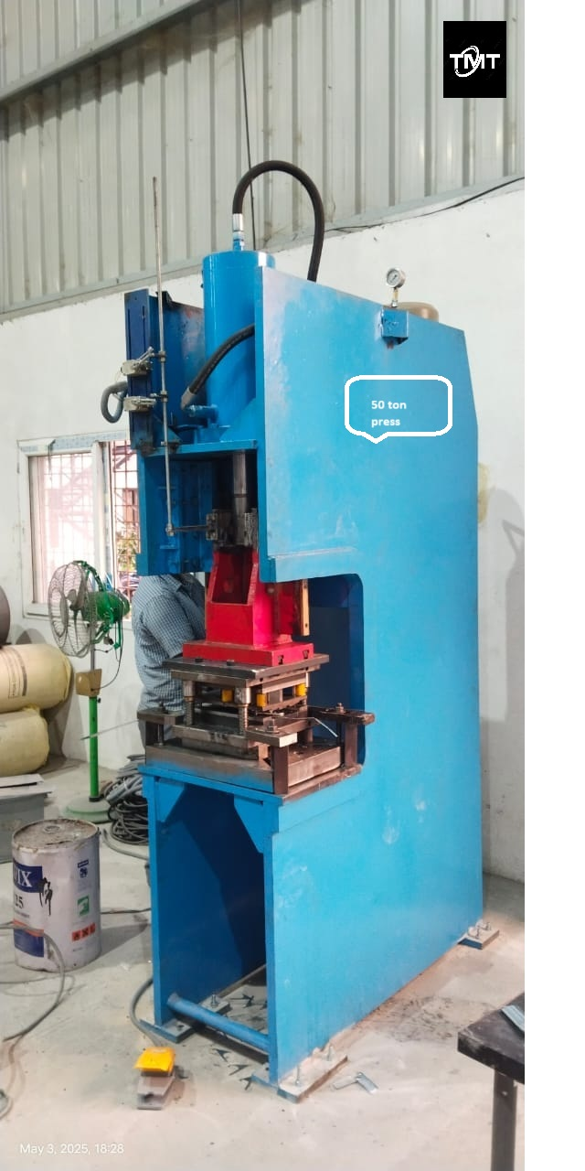

For TECHNO MACHINE TOOLS

T. SIVARAMAKRISHNA

TMT/Power electricals/S0457/2025 09 -09- 2025

To,
Power Electrical Engineers,
Mobile: 9848089363
Kukatpally, Hyderabad.

Dear sir,

Sub :-Supply of 30MT C-TYPE HYDRAULIC PRESS.

This is reference to your enquiry for the hydraulic press; we offer our least possible price as under.

C TYPE PRESS :

1) Tonnage : 30 MT.

S No | Description of the unit | Offer
1. | C Type Hydraulic Press with capacity 30 Tons. with Power pack of 7.5 HP motor and with complete electrical.  Clear pass 550 mm  Hydraulic power pack along with motor 7.5 hp motor  Tank 200 lts  Yuken vane pump 16 lpm  Piston pump 4.0 lpm  Pressure gauge 1 No  Level indicator 1 No  Section filter 1 No  Return line filter 1 No  Section strainer 1 no  Manifold block 1 no  Pressure control valve 1 no  Solenoid operated direction control valve 1 no’s  Pipes and fittings.  Bell housing 1 no  Pressure gauge 0-250 kg 1 no  Flexible houses 2 no’s  Nylon gear coupling 1 no | Rs 3,80,000/-  (Rupees Three Lakhs Eighty Thousand only)

SPECIFICATIONS FOR THE HYDRAULIC PRESS MACHINE WITH 30Ton

1. Tonnage : 30 M.T.

2. Clearance between Housings : 550mm

3. Daylight : 630 mm

4. Ram stroke. : 400 M.M.

5. Open height. : 630 M.M.

6. Closed height. : 230 M.M.

7. Depth of Throat. : 450 M.M.

- Ram speeds.

a) Approach. : 12 M.M. per Sec.

b) Pressing. : 2 M.M. per Sec.

c) Return. : 20 M.M. per Sec.

9. Motor capacity. : 7.5 H.P. (Crompton)

10. Bed size. : 450 x 550 M.M.

12. Cost of Machine. : Rs. 3,80,000/- + Taxes.

13. Mode of payment. : As per the quotation.

14. Delivery. : As per the quotation.

GENERAL TERMS & CONDITIONS:

1 Price quoted per unit ex-work. Hyderabad.
2 Following charges are additional to your account.
- Freight Charge : As actual to be borne by you.
- Sales Tax : 18% extra GST.
- Packing charge : As actual to be borne by you.
- Insurance : As actual to be borne by you.
3Payment : 50% advance along with order another 25%
advance after 3 weeks from first advance and
balance before delivery but after inspection at our
works.
- Delivery : 5-6 weeks from date of techno-commercially clear
purchase order.
- Validity : One month from the date of submission.
- Inspection : Inspection at our works prior to dispatch.
- Warranty : The machine is warranted for a period of 12
months from the date of dispatch against any
manufacturing defects/faulty material or bad
workmanship of any part or component but not
against any kind of abnormal or improper use of
machine. Defective part or component will be
replaced or repaired free of cost. Electrical
components are outside the scope of this
warranty.
- Commissioning : Erection & commissioning done by you, but if
required technical support & guidance provide by
us at additional cost.
NOTE:

- Oil is not in scope of our supply.
- Raw material for trial is arranged by you at your cost.

We are sure you will find our offer in line with your requirements. Should you require any further clarification please call us on mobile number 9246221106.

Thanking you and assuring you of our best services.

For TECHNO MACHINE TOOLS

T.SIVARAMAKRISHNA.
TMT/Power electricals/S0457/2025 09 -09- 2025

To,
Power Electrical Engineers,
Mobile: 9848089363
Kukatpally, Hyderabad.

Dear sir,

Sub :-Supply of 100 MT C-TYPE PUNCHING PRESS.

This is reference to your enquiry for the hydraulic press; we offer our least possible price as under.

C TYPE PRESS :

1) Tonnage : 100 MT.

S No | Description of the unit | Offer
1. | C Type Hydraulic Press with capacity 100 Metric tons. With Power pack of 15 HP motor and with complete electrical.  Hydraulic power pack along with motor 15 hp motor  Tank 200 lts  Yuken vane pump 180 lpm  Piston pump 30.0 lpm  Pressure guage 1 No  Level indicator 1 No  Section filter 1 No  Return line filter 1 No  Section strainer 1 no  Manifold block 1 no  Pressure control valve 1 no  Solenoid operated direction control valve 1 nos  Pipes and fittings.  Bell housing 1 no  Pressure guage 0-250 kg 1 no  Flexible houses 2 nos  Nylon gear coupling 1 no | Rs 5,80,000/-  (Rupees Five Lakhs Eighty Thousand only)

SPECIFICATIONS FOR THE HYDRAULIC PRESS MACHINE WITH 100MT

1. Tonnage : 100 M.T.

2. Clearance between Housings : 450mm

3. Daylight : 250 mm

4. Ram stroke. : 150 M.M.

5. Open height. : 450 M.M.

6. Closed height. : 300 M.M.

7. Depth of Throat. : 350 M.M.

- Ram speeds.

a) Approach. : 12 M.M. per Sec.

b) Pressing. : 2 M.M. per Sec.

c) Return. : 20 M.M. per Sec.

9. Motor capacity. : 15 H.P. (Crompton)

10. Bed size. : 350 x 300 M.M.

12. Cost of Machine. : Rs.5,80,000/- + Taxes.

13. Mode of payment. : As per the quotation.

14. Delivery. : As per the quotation.

GENERAL TERMS & CONDITIONS:

1 Price quoted per unit ex-work. Hyderabad.
2 Following charges are additional to your account.
- Freight Charge : As actual to be borne by you.
- Sales Tax : 18% GST extra.
- Packing charge : As actual to be borne by you.
- Insurance : As actual to be borne by you.
3Payment : 50% advance along with order another 25%
advance after 3 weeks from first advance and
balance before delivery but after inspection at our
works.
- Delivery : 2-3 weeks from date of techno-commercially clear
purchase order.
- Validity : One month from the date of submission.
- Inspection : Inspection at our works prior to dispatch.
- Warranty : The machine is warranted for a period of 12
months from the date of dispatch against any
manufacturing defects/faulty material or bad
workmanship of any part or component but not
against any kind of abnormal or improper use of
machine. Defective part or component will be
replaced or repaired free of cost. Electrical
components are outside the scope of this
warranty.
- Commissioning : Erection & commissioning done by you, but if
required technical support & guidance provide by
us at additional cost.
NOTE:

- Oil is not in scope of our supply.
- Raw material for trial is arranged by you at your cost.

We are sure you will find our offer in line with your requirements. Should you require any further clarification please call us on mobile number 9246221106.
Thanking you and assuring you of our best services.

For TECHNO MACHINE TOOLS

T.SIVARAMAKRISHNA
TMT/Power electricals/S0457/2025 09 -09- 2025

To,
Power Electrical Engineers,
Mobile: 9848089363
Kukatpally, Hyderabad.

Dear Sir,

Sub: - QUOTATION FOR HYDRAULIC SHEARING MACHINE

Thank you very much for your enquiry regarding your requirement of Hydraulic Shearing Machine mainly for MS Sheets. We are glad to inform you that we would be in a position to supply you the required equipment. Given below are the required specifications and description of the machine and our terms and conditions.

S No | Description of the unit | Offer
1. | Hydraulic shearing machine with fixed rake angle and shearing capacity 3 Meters and 4 mm MS Sheet, along with Power pack 10.0 HP motor and other electrical fittings. | Rs 8,45,000/-
2 | NC back gauge with 900 mm | Rs 2,90,000/-

SPECIFICATIONS FOR THE HYDRAULIC SHEARING MACHINE WITH CUTTING CAPACITY 3000 M.M. WIDTH AND 4 M.M. THICKNESS.

1. CUTTING CAPACITY IN MS : 3000 X 4 MM.

2. RAKE ANGLE (variable) : 1.5 DEGREES

3. STROKES PER MINUTE : 12-16 Nos

4. NUMBER OF HOLD DOWNS : 13 Nos

5. BACK GAUGE (manual) : 550 M.M.

6. MOTOR HP : 10 HP (Crompton)
- OVERALL DIMMENSIONS :

a) LENGTH : 3500 M.M.

b) BREADTH : 1200 M.M.

c) HEIGHT : 1800 M.M.

8. BED SIZE. : 3000 X 550 M.M.

9. Balade Thickness : 24 mm

GENERAL TERMS & CONDITIONS:

- Price quoted per unit ex-work. Hyderabad.
- Following charges are additional to your account.
- Freight Charge : As actual to be borne by you.
- Sales Tax : Extra as applicable
- Packing charge : As actual to be borne by you.
- Insurance : As actual to be borne by you.
- Payment : 50% advance along with order balance before delivery but after inspection at our works.
- Delivery : With 50% advance 6 weeks from date of advance received
- Validity : One month from the date of submission.
- Inspection : Inspection at our works prior to dispatch.
- Warranty : The machine is warranted for a period of 12 months from the date of dispatch against any manufacturing defects/ faulty material or bad workmanship of any part or component but not against any kind of abnormal or improper use of machine. Defective part or component will be replaced or repaired free of cost. Electrical components are outside the scope of this warranty.
- Commissioning : Erection & commissioning done by you, but required technical support & guidance provide by us at additional cost.

NOTE:
- Oil is not in scope of our supply.
- Raw material for trial is to be arranged by you at your cost.

We are sure you will find our offer in line with your requirements. Should you require any further clarification please contact 9246221106
Thanking you and assuring you of our best services

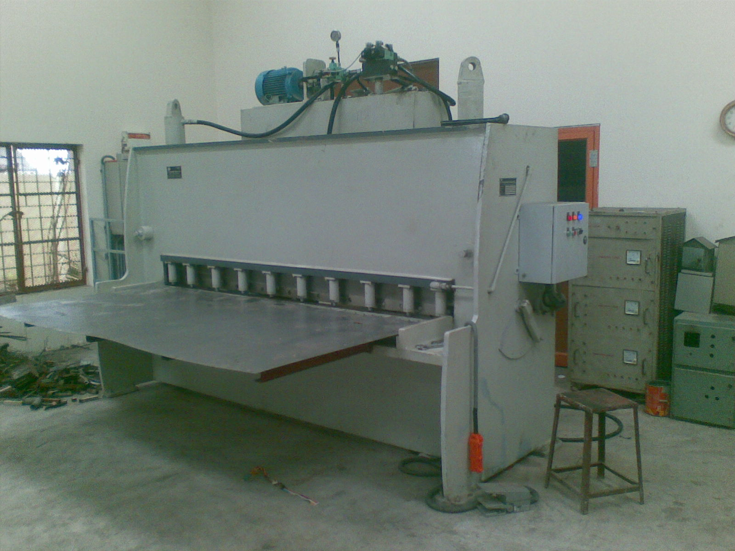

For Techno Machine Tools

(T. Sivaramakrishna)

TMT/Power electricals/S0457/2025 09 -09- 2025

To,
Power Electrical Engineers,
Mobile: 9848089363
Kukatpally, Hyderabad.

Dear sir,

Sub:- Supply of HYDRAULIC PRESS BRAKE MACHINE.

Thank you very much for your enquiry regarding your requirement of hydraulic press brake. We are glad to inform you that we would be in a position to supply you the required equipment. Given below are the required specifications and description of the machine and our terms and conditions.

PRESS BRAKE :

1) Size : 3000 X 4 M.M.

2) Tonnage : 100 M.T.

S No | Description of the unit | Offer
1. | Hydraulic Press Brake with bending capacity 3.0 Meters and 4 mm MS Sheet, 100 MT load capacity with Power pack of 7.5 HP motor along with one set Standard Die and Punch. | Rs 8,50,000/-
2 | Nc back gauge up to 750 mm wide | Rs 2,75,000/-

SPECIFICATIONS FOR THE HYDRAULIC PRESS BRAKE MACHINE WITH 3000 M.M. WIDTH AND 4 M.M. THICKNES.

1. Tonnage : 100 M.T.

2. Clearance between Housings : 2500 M.M.

3. Bending capacity in M.S. : 3000 x 4 M.M.

4. Ram stroke. : 150 M.M.

5. Open height. : 350 M.M.

6. Closed height. : 200 M.M.

7. Depth of Throat. : 300 M.M.

- Ram speeds.

a) Approach. : 22 M.M. per Sec.

b) Pressing. : 3 M.M. per Sec.

c) Return. : 40 M.M. per Sec.

9. Motor capacity. : 20 H.P. (Crompton)

10. Punch. : 3000 x 185 x 65 M.M.
( ‘GROOSE NECK’ type)

11. Bed size. : 3000 x 255 x 75 M.M.

12. Cost of Machine. : Rs.8,50,000/- + Taxes.

13. Mode of payment. : As per the quotation.

14. Delivery. : As per the quotation.

GENERAL TERMS & CONDITIONS:

- Price quoted per unit ex-work. Hyderabad.
- Following charges are additional to your account.
- Freight Charge : As actual to be borne by you.
- Sales Tax : Extra as applicable
- Packing charge : As actual to be borne by you.
- Insurance : As actual to be borne by you.
- Payment : 50% advance along with order balance before delivery but after inspection at our works.
- Delivery : within 45 days
- Validity : One month from the date of submission.
- Inspection : Inspection at our works prior to dispatch.
- Warranty : The machine is warranted for a period of 12 months from the date of dispatch against any manufacturing defects/ faulty material or bad workmanship of any part or component but not against any kind of abnormal or improper use of machine. Defective part or component will be replaced or repaired free of cost. Electrical components are outside the scope of this warranty.
- Commissioning : Erection & commissioning done by you, but required technical support & guidance provide by us at additional cost.

NOTE:
- Oil is not in scope of our supply.
- Raw material for trial is to be arranged by you at your cost.

We are sure you will find our offer in line with your requirements. Should you require any further clarification please contact 9246221106
Thanking you and assuring you of our best services

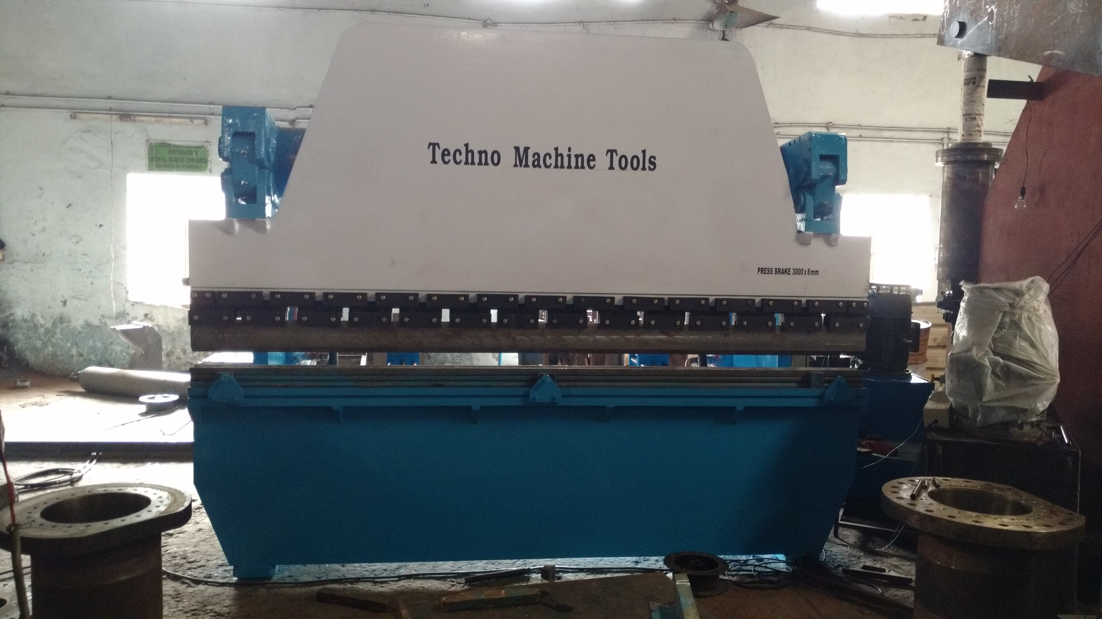
For Techno Machine Tools

( T. Sivaramakrishna)

